EXPERIMENT 5
STEP-BY-STEP LOG
Report Generation using Relational and Multidimensional Data on the Star Schema using Power BI

1. Aim
To generate relational and multidimensional reports on the star schema developed in Experiment 3 and extended in Experiment 4 using Power BI. The experiment uses table and matrix visuals, a geographic hierarchy, comparative charts, and an interactive dashboard to support business analysis.

2. Objectives
- Verify the existing star-schema relationships and the Geo_Hierarchy in the Power BI data model.
- Create a relational report using transaction-level fields, sorting, filtering, and data export.
- Create a matrix report using the Region–State–City hierarchy and aggregated measures.
- Build comparative charts to analyze sales and profit by category, region, customer, and year.
- Combine key measures and slicers into an interactive dashboard and interpret the reports.

3. Tools / Software Required
- Microsoft Power BI Desktop.
- The Power BI (.pbix) file saved at the end of Experiment 4, containing Fact_Sales, Dim_Customer, Dim_Product, Dim_Region, Dim_Date, Geo_Hierarchy, and the Slice, Dice, and Drill report pages.

4. Dataset and Model
Use the same sales dataset and star-schema model from the previous experiments. The fact table is Fact_Sales. The dimension tables are Dim_Customer, Dim_Product, Dim_Region, and Dim_Date. The geographic hierarchy is Region > State > City in Dim_Region. Measures used in this experiment include Total Sales, Total Profit, Quantity, and Total Orders where available in the existing model.

5. Theory
A relational report presents detailed records in rows and columns and is useful for checking individual transactions. A multidimensional report aggregates measures across dimensions and hierarchies, allowing users to drill from a regional summary down to state and city levels. Comparative charts reveal patterns and differences that may be difficult to notice in a transaction table. An interactive dashboard combines important measures and visuals and lets users explore results with slicers.

6. Procedure

Part 1: Reopen and Verify the Model
Step 1: Open the previous Power BI file.
Launch Power BI Desktop and open the .pbix file saved at the end of Experiment 4. Wait for the report and model to load.
Step 2: Verify relationships.
Select Model view. Confirm that Fact_Sales is related to Dim_Customer, Dim_Product, Dim_Region, and Dim_Date. Verify that each fact-to-dimension relationship shows the expected many-to-one (*:1) cardinality and that the relationships are active.
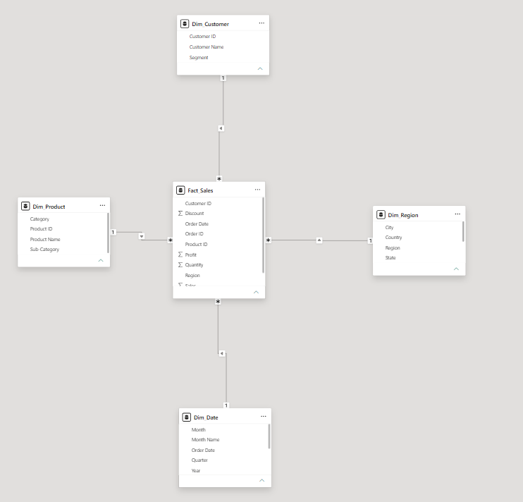
Step 3: Verify Geo_Hierarchy.
In the Dim_Region table, confirm that Geo_Hierarchy contains the levels Region, State, and City in that order. If the hierarchy was already created in Experiment 4, do not recreate it unnecessarily.
Step 4: Check existing report pages.
Return to Report view and check the Slice, Dice, and Drill pages. Confirm that their visuals load and display data values rather than errors or blanks.
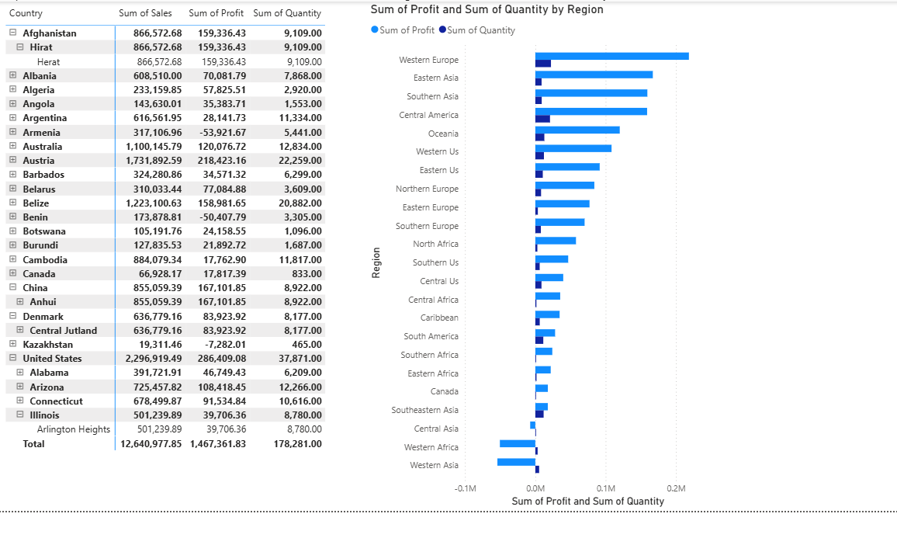

Part 2: Build the Relational Report
Step 5: Add a report page.
Click the plus (+) icon to add a page. Rename the page Relational Report.
Step 6: Insert a Table visual.
Select the Table visual from the Visualizations pane and resize it to provide enough space for the required fields.
Step 7: Add fields in the required order.
Add these fields to the table in this order: Order ID (Fact_Sales), Customer Name (Dim_Customer), Product Name (Dim_Product), Region (Dim_Region), Sales (Fact_Sales), and Profit (Fact_Sales). Check that the columns display sensible values.
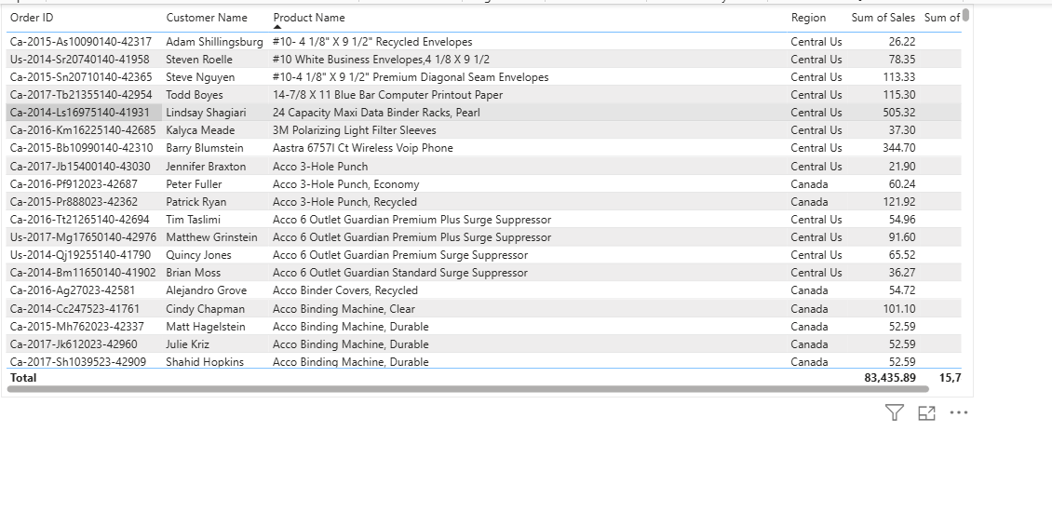
Step 8: Sort by Sales.
Click the Sales column header once to sort the records from highest sales to lowest sales. If the first click sorts ascending, click again until the highest values appear first.
Step 9: Filter for positive profit.
In the Filters pane, apply a visual-level filter to Profit and set the condition to is greater than 0. Apply the filter and confirm that the displayed records have positive profit.
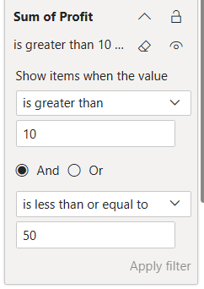
Step 10: Export the table data.
Right-click the table visual and select Export data. Save the exported file in Excel/CSV format as offered by Power BI. Open the export if needed to verify that the rows were exported.
Step 11: Record the observation.
Note the number of rows remaining after the Profit > 0 filter and identify the customer and product at the top of the Sales-sorted table. Enter the actual values from your report; do not estimate them.
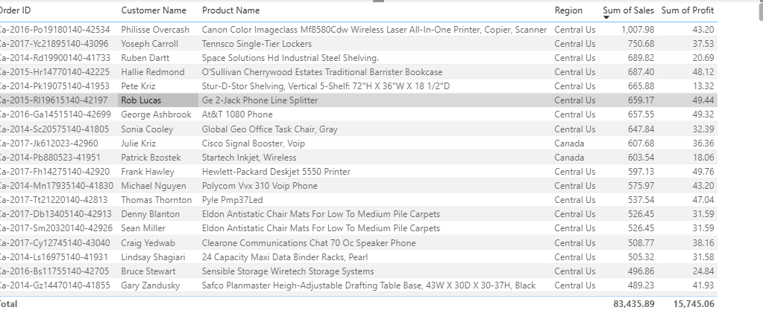

Part 3: Build the Multidimensional Report
Step 12: Add the matrix report page.
Add a new report page and rename it Matrix Report.
Step 13: Insert a Matrix visual.
Select the Matrix visual from the Visualizations pane and resize it to suit the report page.
Step 14: Add the geographic hierarchy to Rows.
Drag Geo_Hierarchy from Dim_Region into the Rows well of the Matrix visual. The hierarchy should contain Region, State, and City.
Step 15: Add measures to Values.
Add Total Sales, Total Profit, and Quantity to Values. Use the measures already available in the model. Quantity should aggregate from Fact_Sales; check the aggregation shown by Power BI and use Sum for the quantity field if appropriate.
Step 16: Drill down through the hierarchy.
Use the matrix drill/expand controls to move from Region to State and then City. Observe how the values are broken down at each level.
Step 17: Drill back up.
Use the drill-up control or collapse the hierarchy to return from City to State and Region levels.
Step 18: Compare with Experiment 4.
Select the same state used on the Drill page in Experiment 4 and compare the city-level numbers with the corresponding Matrix Report values. Use the same filters and aggregation level for a fair comparison.
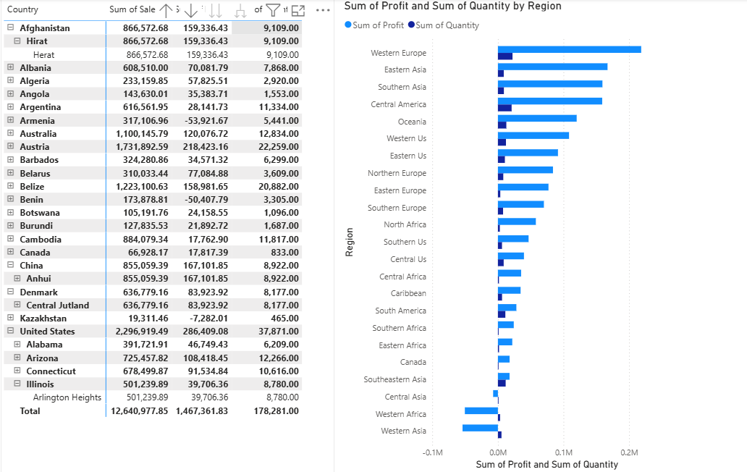.

Part 4: Build the Comparative Analysis Report
Step 19: Add the comparative analysis page.
Add a new page and rename it Comparative Analysis.
Step 20: Add Sales by Category and Profit by Region.
Copy the corresponding charts from Experiment 3, or rebuild them on this page. Verify that Category is used for the sales category comparison and Region for the profit comparison.
Step 21: Create Top 10 Customers by Sales.
Insert a bar chart. Place Customer Name on the Axis and Total Sales (or Sales aggregated as a sum) in Values. In the visual-level filters, set Customer Name to Top N, enter 10, use Total Sales as the By value, and apply the filter.
Step 22: Create Sales Trend by Year.
Insert a line chart. Place Year from Dim_Date on the X-axis and Total Sales in Values. Check that years are ordered chronologically and the sales aggregation is correct.
Step 23: Set chart titles.
Give the four visuals these titles: Sales by Category, Profit by Region, Top 10 Customers by Sales, and Sales Trend by Year. Arrange the visuals so that all four can be read clearly.
Step 24: Compare the visual insights.
Compare the chart patterns with the Relational Report. Record which categories or regions stand out, which customers rank in the top 10, and how sales change by year. Base observations on the actual visuals.
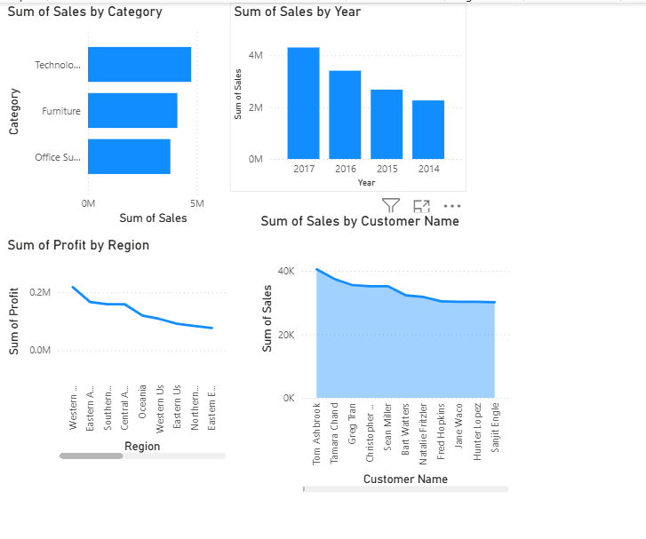

Part 5: Create the Interactive Dashboard
The Experiment 5 PDF labels this part as the interactive dashboard and specifies a dashboard page with KPI cards and three slicers. The following steps follow those requirements.
Step 25: Create the dashboard page.
Add a new page and rename it Dashboard. Keep the layout uncluttered so the KPI cards, slicers, and charts are easy to read.
Step 26: Add KPI cards.
Insert Card visuals for Total Sales, Total Profit, and Total Orders. Use the corresponding existing measures. If Total Orders is not already defined, use the appropriate existing order-count measure or create the measure according to your lab model instructions.
Step 27: Add the dashboard visuals.
Add or copy suitable visuals from the Comparative Analysis page so that the dashboard presents the main sales and profit patterns alongside the KPI cards.
Step 28: Add three slicers.
Add slicers for Region, Category, and Year. Use fields from the appropriate dimension tables: Region from Dim_Region, Category from Dim_Product, and Year from Dim_Date.
Step 29: Verify slicer interactions.
Select a value in each slicer one at a time. Confirm that the KPI cards and dashboard visuals respond to the selection. If a visual does not respond, use Format > Edit interactions to check that filtering is enabled for that visual.
Step 30: Clear filters and save.
Clear slicer selections to return the dashboard to its unfiltered state. Save the .pbix file and confirm that the Dashboard page remains available.
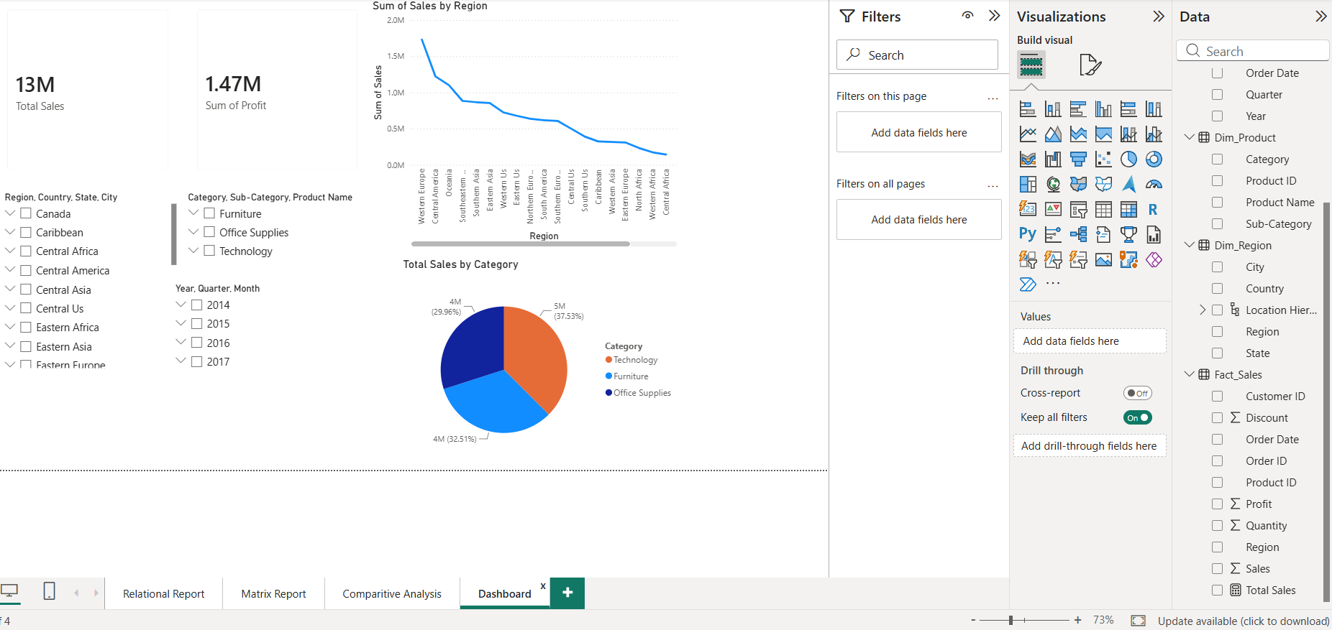

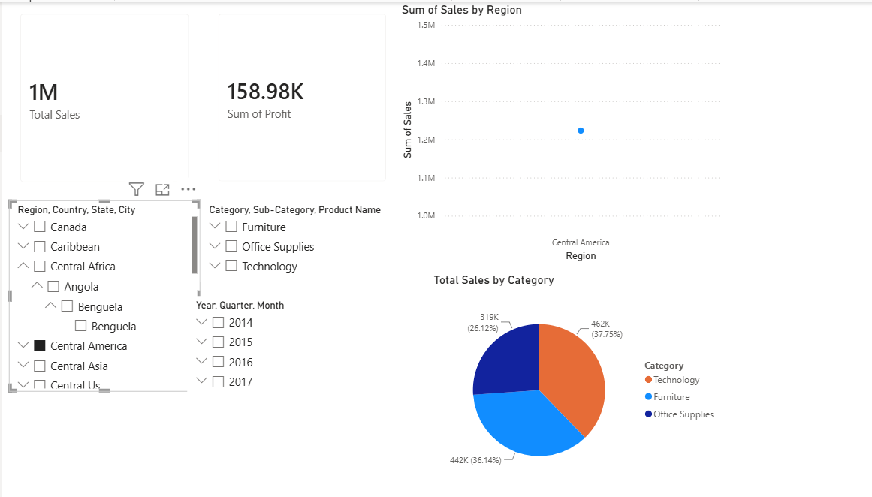

Part 6: Summary and Interpretation
Complete the summary table below using observations from your own Power BI report.
Report Type | Fields or Measures Used | Key Observation | Business Use
Relational Report | Order ID, Customer Name, Product Name, Region, Sales, Profit | Write the row count and the top customer/product after filtering. | Transaction-level checking and investigation.
Multidimensional Report | Geo_Hierarchy, Total Sales, Total Profit, Quantity | Record the regional/state/city pattern and the comparison with the Drill page. | Summarized geographic analysis and drill-down.
Comparative Analysis | Category, Region, Customer Name, Year, Total Sales | Record key category, regional, customer, and yearly trends. | Compare performance and identify patterns.
Dashboard | Total Sales, Total Profit, Total Orders, Region, Category, Year | Record the main KPI values and how slicers change the views. | Quick monitoring and interactive review.

7. Result
Relational and multidimensional reports were prepared using the existing star schema in Power BI. The relational table supports transaction-level analysis through sorting, filtering, and export. The matrix report uses Geo_Hierarchy to summarize and drill into geographic levels. Comparative charts and an interactive dashboard bring together different views to support business interpretation. Complete this result statement after verifying the report and recording your actual observations.

8. Learning Outcomes
- Generate relational reports from transaction-level data (CO3, BT3).
- Create multidimensional reports using an existing hierarchy and star schema (CO3, BT3).
- Apply sorting, filtering, aggregation, and drill operations (CO3, BT3).
- Create an interactive dashboard with KPI cards and slicers (CO3, BT3).
- Interpret and compare insights from relational, multidimensional, and visual reports (CO3, BT4).

